r

W.L. Gore -CDMA Project

Dynamics Marketing Implementation

Functional Requirements

Table of Contents

Table of Contents 1

1 Document Purpose 2

Overview 2

Project Objectives 3

Dynamics 365 Marketing Functional Requirements 4

1.Configuration of Custom Tables in Dynamics Marketing 5

2.Configuration of 12 Salesforce existing Journey in Dynamics Marketing 14

2.1 Segment based 15

2.2 Form Trigger Based: 15

Double Opt In – 1114750 Workwear Double opt –In 15

3.Configuration of Email domains and sender profiles 16

4.Configuration of 18 Emails 20

5.Configuration of 20 Email Templates 21

6.Configuration of Gore-Tex One Transactional Emails 22

8.Configuration of 1 Marketing segment-based Journey (For training purpose) 23

9.Configuration of 1 Trigger-based Journey (For training purpose) 23

10. Configuration of 1 native subscription management from D365 Marketing 24

11. Configure Consent Management feature and 1 Subscription List 24

12.Configuration of Lead Scoring basic model 25

13. Marketing Data Migration 25

14. Configuration of Marketing Security Roles (1 Admin ,1 General user) ,6 BU, Access control 26

15. Creation of a 1 Native D365 reporting dashboard for Marketing Campaigns 26

4 Customer Approval 28

sec

# 1 Document Purpose

The Functional Requirement document describes application related changes required to meet the desired business requirements as they relate to the application identified for deployment.

  This list of requirements approved will be considered final upon acceptance as indicated by the customer signature.

* + 1. **Version History**

|  |  |  |  |
| --- | --- | --- | --- |
| **Version** | **Author** | **Date** | **Notes** |
| 1.0 | Shraddha Jaitly | 10/20/2023 | Initial Draft |
|  | Shraddha Jaitly | 11/1/2023 | Revision -Added refined architecture diagram |
|  |  |  |  |

Overview

W. L. Gore is currently on Salesforce CDP and want to move to Microsoft Customer Insights. Gore is also looking to move away from Salesforce for marketing and into the Dynamics 365 Marketing system.

## Project Objectives

**Dynamics 365 Marketing in-scope summary**

* Configuration of custom data schema
* Configuration of Email Domains and sender profiles
* Configuration of Gore Tex one Transactional Emails
* Configuration of 20 Email Templates
* Configuration of 18 Emails
* Configuration of 3 Marketing Landing Pages
* Configuration of 12 Salesforce existing Journey in Dynamics Marketing
* Configuration of 1 Segment based Journey (*For Gore Training purposes*)
* Configuration of 1 Trigger based Journey (*For Gore Training purposes*)
* Configuration of 1 native subscription management from D365 Marketing
* Configure Consent Management feature and 1 Subscription List
* Configuration of Lead Scoring basic model (*For Gore Training purposes*)
* Marketing Data Migration
* Configuration of Marketing Security Roles (1 Admin ,1 General user) ,6 BU, Access control
* Creation of a 1 Native D365 reporting dashboard for Marketing Campaigns
* Creation of 1 Trigger for the Trigger Journey
* Creation of 4 Suppression List
* Marketing Train the Trainer – Application use
* Marketing Train the Trainer – Admin use
* Marketing Testing Plan
* Marketing UAT
* Marketing Go-Live planning and deployment
* Marketing Demo videos and help guides

# Dynamics 365 Marketing Functional Requirements

**Overall Marketing Architecture**

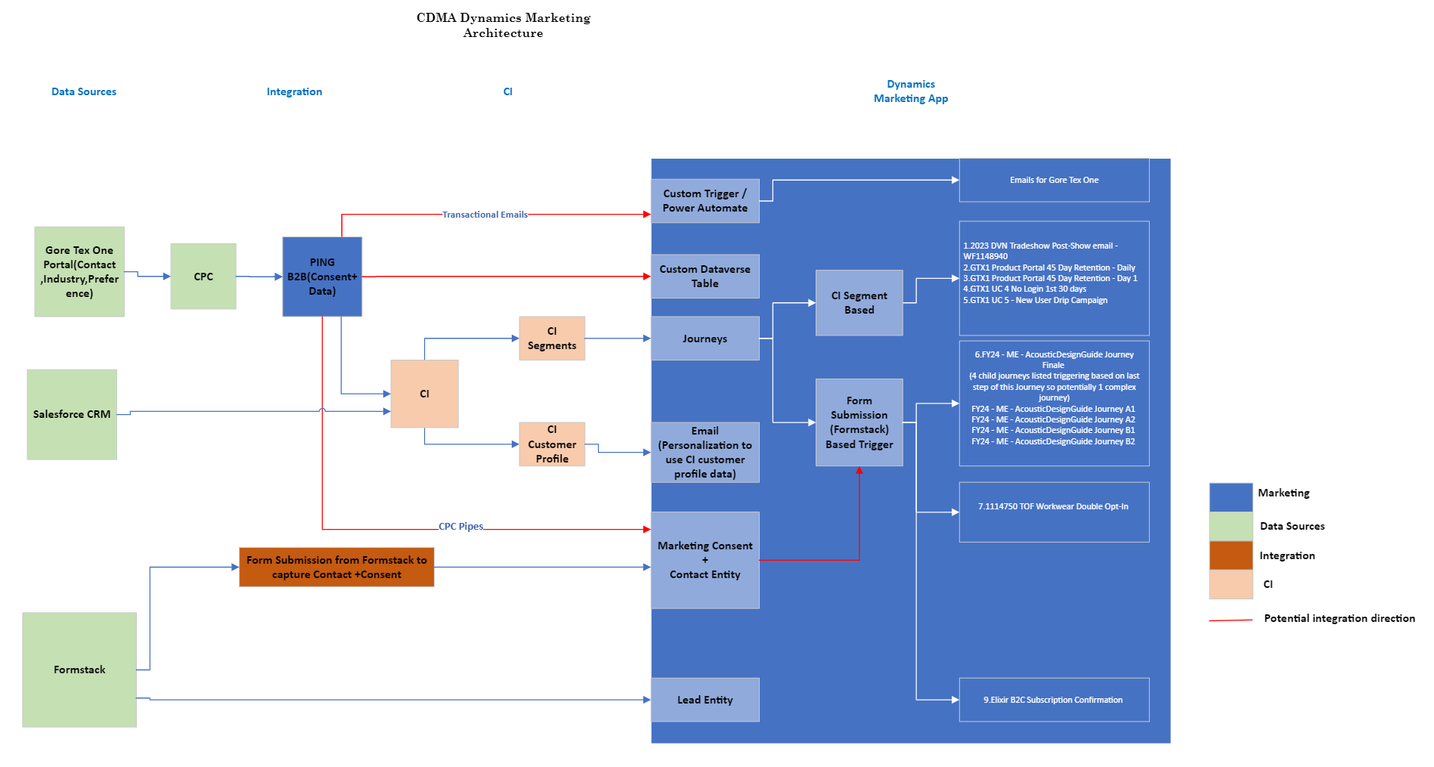

Data Flow Architecture

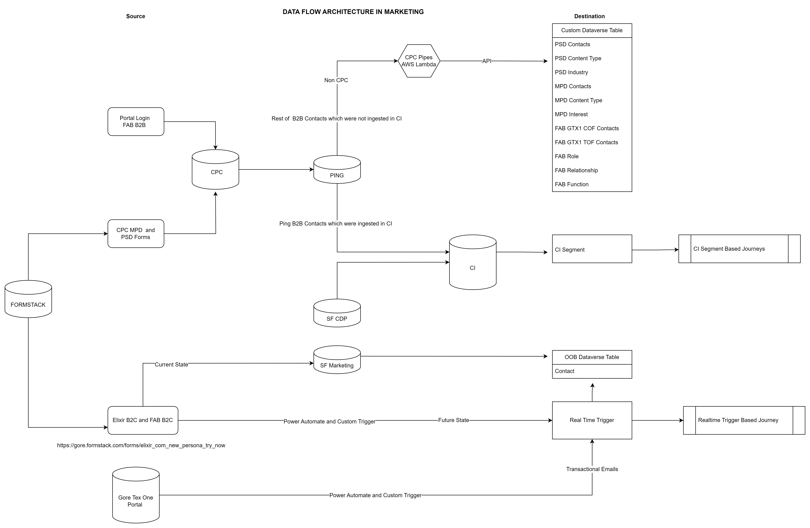

## 1.Configuration of Custom Tables in Dynamics Marketing

We would need to create custom Tables to store the Data, Consent into Tables and relate it to Contact Entity. These tables are currently present in Salesforce and will be replaced with Dataverse tables in Future State

Existing Dataverse Tables: Contact Entity

New Dataverse Tables: We need to create the below tables in Dataverse which would provide the data structure to store CPC data into Marketing

CPC PSD Contact

CPC PSD ContentType

PSD Contact-ContentType

CPC PSD Industry

CPC PSD Contact-Industry

CPC MPD Contact

CPC MPD ContentType

CPC MPD Contact-ContentType

CPC MPD Interest

CPC MPD Contact-Interest

CPC Gore Regions

CPC FAB-COF-GTX1 Contact

CPC FAB-TOF-GTX1 Contact

CPC FAB Role

CPC FAB Function

CPC FAB Relationship

Fields:

Below is the list of fields in data structure to be created in Contact Entity in Dataverse

Assumptions: It is assumed that the CPC Gore team would be responsible for sending this data into Dataverse via API once the Data structure is in place

**Contact**

|  |  |  |  |
| --- | --- | --- | --- |
| Table | Attribute | Type | Length |
| Contact | Account Name | Text | 150 |
| Contact | Account Market | Text | 100 |
| Contact | Account Submarket | Text | 100 |
| Contact | Account Business Group | Text | 100 |
| Contact | Campaign Detail | Text | 100 |
| Contact | Campaign Name | Text | 100 |
| Contact | City | Text | 100 |
| Contact | Country | Text | 50 |
| Contact | Date Created | Date |  |
| Contact | Date Modified | Date |  |
| Contact | Degree | Text | 50 |
| Contact | Division | Text | 20 |
| Contact | Email | Email |  |
| Contact | Encrypted Federated Id | Text | 254 |
| Contact | Federated Id | Text | 254 |
| Contact | Fellow Status Year | Number |  |
| Contact | First Name | Text | 100 |
| Contact | Job Function | Text | 100 |
| Contact | Function Other | Text | 100 |
| Contact | Graduation Month | Number |  |
| Contact | Graduation Year | Number |  |
| Contact | Language | Text | 50 |
| Contact | Last Name | Text | 100 |
| Contact | Locale | Text | 10 |
| Contact | Major | Text | 100 |
| Contact | Mobile Phone | PhoneNumber |  |
| Contact | Modified By | Text | 100 |
| Contact | National Provider Id | Text | 50 |
| Contact | Playing Style | Text | 50 |
| Contact | Postal Code | Text | 10 |
| Contact | Elixir Preferences Newsletter | Boolean |  |
| Contact | Elixir Preferences ProductTesting | Boolean |  |
| Contact | Elixir Preferences Promotions | Boolean |  |
| Contact | Preferred Brand | Text | 100 |
| Contact | Preferred Language | Text | 50 |
| Contact | Primary Instrument | Text | 50 |
| Contact | Product Trial Consent | Boolean |  |
| Contact | Registration Source | Text | 100 |

**CPC Tables**

|  |  |  |  |  |
| --- | --- | --- | --- | --- |
| Table | Attribute | Type | Default Val | Length |
| CPC PSD Contact | FederatedId | Text |  | 254 |
| CPC PSD Contact | Title | Text |  | 20 |
| CPC PSD Contact | FirstName | Text |  | 100 |
| CPC PSD Contact | LastName | Text |  | 100 |
| CPC PSD Contact | Email | Email |  | 254 |
| CPC PSD Contact | MobilePhone | PhoneNumber |  |  |
| CPC PSD Contact | PostalCode | Text |  | 10 |
| CPC PSD Contact | AccountName | Text |  | 150 |
| CPC PSD Contact | AccountCountry | Text |  | 50 |
| CPC PSD Contact | AccountStateProvince | Text |  | 50 |
| CPC PSD Contact | Language | Text |  | 50 |
| CPC PSD Contact | ConsentStatus | Boolean | FALSE |  |
| CPC PSD Contact | ConsentValue | Text |  | 50 |
| CPC PSD Contact | ConsentModificationDate | Date |  |  |
| CPC PSD Contact | SubscriberModificationDate | Date |  |  |
| CPC PSD Contact | SubscriberModifiedBy | Text |  | 50 |
| CPC PSD Contact | RegistrationSource | Text |  | 100 |
| CPC PSD Contact | Locale | Text |  | 10 |
| CPC PSD Contact | EncryptedFederatedId | Text |  | 254 |
| CPC PSD Contact | CampaignName | Text |  | 100 |
| CPC PSD Contact | CampaignDetail | Text |  | 100 |
| CPC PSD ContentType | ContentTypeId | Text |  | 100 |
| CPC PSD ContentType | ContentType | Text |  | 50 |
| CPC PSD ContentType | Active | Boolean | FALSE |  |
| PSD Contact-ContentType | FederatedId | Text |  | 254 |
| PSD Contact-ContentType | ContentTypeId | Text |  | 100 |
| CPC PSD Industry | IndustryId | Text |  | 100 |
| CPC PSD Industry | Industry | Text |  | 100 |
| CPC PSD Industry | SubIndustry | Text |  | 100 |
| CPC PSD Industry | ProductCategory | Text |  | 100 |
| CPC PSD Industry | Active | Boolean | FALSE |  |
| CPC PSD Contact-Industry | FederatedId | Text |  | 254 |
| CPC PSD Contact-Industry | IndustryId | Text |  | 100 |
| CPC MPD Contact | FederatedId | Text |  | 254 |
| CPC MPD Contact | NationalProviderId | Text |  | 20 |
| CPC MPD Contact | Title | Text |  | 20 |
| CPC MPD Contact | FirstName | Text |  | 100 |
| CPC MPD Contact | LastName | Text |  | 100 |
| CPC MPD Contact | Email | Email |  | 254 |
| CPC MPD Contact | MobilePhone | PhoneNumber |  |  |
| CPC MPD Contact | PostalCode | Text |  | 10 |
| CPC MPD Contact | Function | Text |  | 50 |
| CPC MPD Contact | FunctionOther | Text |  | 50 |
| CPC MPD Contact | Specialty | Text |  | 50 |
| CPC MPD Contact | SpecialtyOther | Text |  | 50 |
| CPC MPD Contact | FellowStatusYear | Text |  |  |
| CPC MPD Contact | AccountName | Text |  | 150 |
| CPC MPD Contact | AccountCountry | Text |  | 50 |
| CPC MPD Contact | AccountStateProvince | Text |  | 50 |
| CPC MPD Contact | Language | Text |  | 50 |
| CPC MPD Contact | ConsentStatus | Boolean | FALSE |  |
| CPC MPD Contact | ConsentValue | Text |  | 50 |
| CPC MPD Contact | ConsentModificationDate | Date |  |  |
| CPC MPD Contact | SubscriberModificationDate | Date |  |  |
| CPC MPD Contact | SubscriberModifiedBy | Text |  | 50 |
| CPC MPD Contact | RegistrationSource | Text |  | 100 |
| CPC MPD Contact | Locale | Text |  | 10 |
| CPC MPD Contact | EncryptedFederatedId | Text |  | 254 |
| CPC MPD Contact | CampaignName | Text |  | 100 |
| CPC MPD Contact | CampaignDetail | Text |  | 100 |
| CPC MPD ContentType | ContentTypeId | Text |  | 100 |
| CPC MPD ContentType | ContentType | Text |  | 50 |
| CPC MPD ContentType | Active | Boolean | FALSE |  |
| CPC MPD Contact-ContentType | FederatedId | Text |  | 254 |
| CPC MPD Contact-ContentType | ContentTypeId | Text |  | 100 |
| CPC MPD Interest | InterestId | Text |  | 100 |
| CPC MPD Interest | Function | Text |  | 50 |
| CPC MPD Interest | Specialty | Text |  | 50 |
| CPC MPD Interest | Interest | Text |  | 100 |
| CPC MPD Interest | Active | Boolean | FALSE |  |
| CPC MPD Contact-Interest | FederatedId | Text |  | 254 |
| CPC MPD Contact-Interest | InterestId | Text |  | 100 |
| CPC Gore Regions | Country | Text |  | 2 |
| CPC Gore Regions | FullCountryName | Text |  | 50 |
| CPC Gore Regions | GoreShortCountryName | Text |  | 50 |
| CPC Gore Regions | Region | Text |  | 5 |
| CPC Gore Regions | SubRegion | Text |  | 5 |
| CPC FAB-COF-GTX1 Contact | FederatedId | Text |  | 254 |
| CPC FAB-COF-GTX1 Contact | Title | Text |  | 20 |
| CPC FAB-COF-GTX1 Contact | FirstName | Text |  | 100 |
| CPC FAB-COF-GTX1 Contact | LastName | Text |  | 100 |
| CPC FAB-COF-GTX1 Contact | Email | Email |  | 254 |
| CPC FAB-COF-GTX1 Contact | MobilePhone | PhoneNumber |  |  |
| CPC FAB-COF-GTX1 Contact | PostalCode | Text |  | 10 |
| CPC FAB-COF-GTX1 Contact | RelationshipId | Text |  | 100 |
| CPC FAB-COF-GTX1 Contact | Relationship | Text |  | 100 |
| CPC FAB-COF-GTX1 Contact | RelationshipOther | Text |  | 100 |
| CPC FAB-COF-GTX1 Contact | FunctionId | Text |  | 100 |
| CPC FAB-COF-GTX1 Contact | Function | Text |  | 100 |
| CPC FAB-COF-GTX1 Contact | FunctionOther | Text |  | 100 |
| CPC FAB-COF-GTX1 Contact | AccountName | Text |  | 150 |
| CPC FAB-COF-GTX1 Contact | AccountCountry | Text |  | 50 |
| CPC FAB-COF-GTX1 Contact | AccountStateProvince | Text |  | 50 |
| CPC FAB-COF-GTX1 Contact | Language | Text |  | 50 |
| CPC FAB-COF-GTX1 Contact | ConsentStatus | Boolean | FALSE |  |
| CPC FAB-COF-GTX1 Contact | ConsentValue | Text |  | 50 |
| CPC FAB-COF-GTX1 Contact | ConsentModificationDate | Date |  |  |
| CPC FAB-COF-GTX1 Contact | SubscriberModificationDate | Date |  |  |
| CPC FAB-COF-GTX1 Contact | SubscriberModifiedBy | Text |  | 50 |
| CPC FAB-COF-GTX1 Contact | RegistrationSource | Text |  | 100 |
| CPC FAB-COF-GTX1 Contact | CampaignName | Text |  | 100 |
| CPC FAB-COF-GTX1 Contact | CampaignDetail | Text |  | 100 |
| CPC FAB-COF-GTX1 Contact | Locale | Text |  | 10 |
| CPC FAB-COF-GTX1 Contact | EncryptedFederatedId | Text |  | 254 |
| CPC FAB-TOF-GTX1 Contact | FederatedId | Text |  | 254 |
| CPC FAB-TOF-GTX1 Contact | Title | Text |  | 20 |
| CPC FAB-TOF-GTX1 Contact | FirstName | Text |  | 100 |
| CPC FAB-TOF-GTX1 Contact | LastName | Text |  | 100 |
| CPC FAB-TOF-GTX1 Contact | Email | Email |  | 254 |
| CPC FAB-TOF-GTX1 Contact | MobilePhone | PhoneNumber |  |  |
| CPC FAB-TOF-GTX1 Contact | PostalCode | Text |  | 10 |
| CPC FAB-TOF-GTX1 Contact | RelationshipId | Text |  | 100 |
| CPC FAB-TOF-GTX1 Contact | Relationship | Text |  | 100 |
| CPC FAB-TOF-GTX1 Contact | RelationshipOther | Text |  | 100 |
| CPC FAB-TOF-GTX1 Contact | FunctionId | Text |  | 100 |
| CPC FAB-TOF-GTX1 Contact | Function | Text |  | 100 |
| CPC FAB-TOF-GTX1 Contact | FunctionOther | Text |  | 100 |
| CPC FAB-TOF-GTX1 Contact | AccountName | Text |  | 150 |
| CPC FAB-TOF-GTX1 Contact | AccountCountry | Text |  | 50 |
| CPC FAB-TOF-GTX1 Contact | AccountStateProvince | Text |  | 50 |
| CPC FAB-TOF-GTX1 Contact | Language | Text |  | 50 |
| CPC FAB-TOF-GTX1 Contact | ConsentStatus | Boolean | FALSE |  |
| CPC FAB-TOF-GTX1 Contact | ConsentValue | Text |  | 50 |
| CPC FAB-TOF-GTX1 Contact | ConsentModificationDate | Date |  |  |
| CPC FAB-TOF-GTX1 Contact | SubscriberModificationDate | Date |  |  |
| CPC FAB-TOF-GTX1 Contact | SubscriberModifiedBy | Text |  | 50 |
| CPC FAB-TOF-GTX1 Contact | RegistrationSource | Text |  | 100 |
| CPC FAB-TOF-GTX1 Contact | CampaignName | Text |  | 100 |
| CPC FAB-TOF-GTX1 Contact | CampaignDetail | Text |  | 100 |
| CPC FAB-TOF-GTX1 Contact | Locale | Text |  | 10 |
| CPC FAB-TOF-GTX1 Contact | EncryptedFederatedId | Text |  | 254 |
| CPC FAB Role | FederatedId | Text |  | 254 |
| CPC FAB Role | Channel | Text |  | 50 |
| CPC FAB Role | Role | Text |  | 100 |
| CPC FAB Function | FunctionId | Text |  | 100 |
| CPC FAB Function | Function | Text |  | 100 |
| CPC FAB Relationship | RelationshipId | Text |  | 100 |
| CPC FAB Relationship | Relationship | Text |  | 100 |

## 2.Configuration of 12 Salesforce existing Journey in Dynamics Marketing

Journeys are categorized into 2 parts:

Segment based (5) and Trigger based (3)

2.1 Segment based**:** The Journeys which will be configured based on the source of audience as Customer Insights segment.

|  |  |  |
| --- | --- | --- |
| **S.No** | **Journey Name** | **BU** |
| **1.** | 2023 DVN Tradeshow Post-Show email - ~~WF1148940~~ | PSD |
| **2.** | GTX1 Product Portal 45 Day Retention - Daily | FAB B2B |
| **3.** | ~~GTX1 Product Portal 45 Day Retention - Day 1~~ | FAB B2B |
| **4.** | GTX1 UC 4 No Login 1st 30 days | FAB B2B |
| **5.** | GTX1 UC 5 - New User Drip Campaign | FAB B2B |

2.2 Form Trigger Based:These Journeys would be based on Trigger from the Formstack form /Ping API call to send out emails in Real time

|  |  |  |
| --- | --- | --- |
| **S.No** | **Journey Name** | **BU** |
| **6.** | FY24 - ME - AcousticDesignGuide Journey Intro   * FY24 - ME - AcousticDesignGuide Journey Finale * FY24 - ME - AcousticDesignGuide Journey A1 * FY24 - ME - AcousticDesignGuide Journey A2 * FY24 - ME - AcousticDesignGuide Journey B1 * FY24 - ME - AcousticDesignGuide Journey B2 | PSD |
| **7.** | 1114750 TOF Workwear Double Opt-In | FAB B2B |
| **8.** | Elixir B2C Subscription Confirmation | Elixir B2C |

## Double Opt In – 1114750 Workwear Double opt –In

**Approach: Use existing form of Formstack on Site to Trigger Journey based on form submission** [**https://www.goretexprofessional.com/uk/workwear-registration**](https://www.goretexprofessional.com/uk/workwear-registration)

**Use Case:** TOF Workwear Event Triggers the email based on users preferred language with a sign-up link. Once the user fills out the sign-up form it triggers a confirmation email for the user to confirm their email to Opt in.

* User will sign up here <https://www.goretexprofessional.com/uk/workwear-registration> this will Trigger the below Action on Preferred language (It can be branched based on Language).We need to add branching in Power Automate so it can be scaled to other languages if needed in future.
* Real-time Marketing Trigger will kick off based on form submission of Formstack form
* Create 1 Email for Workwear Double Opt In – 1114750 Workwear Double Opt In –UK

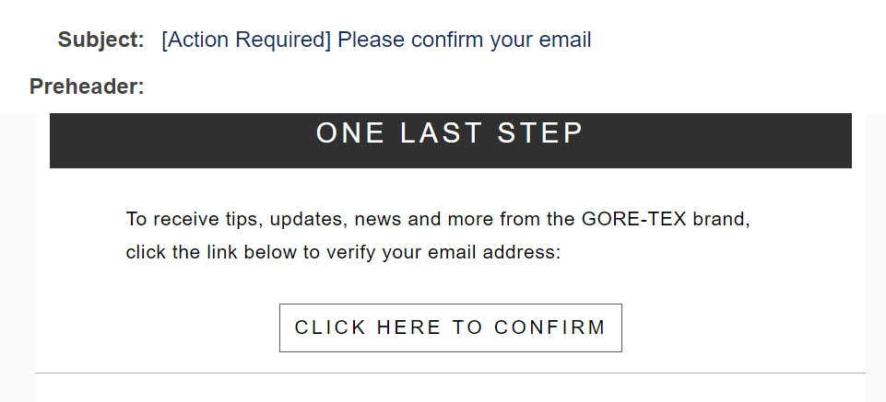

* Within Email we need to create Hyperlink which when clicked would trigger an action “Email link clicked” from within the Journey.
* After clicking on “Click here to confirm” the contact should be automatically redirected to a thank you/success page.
* The hyperlinks for success URLs are as below

<https://www.goretexprofessional.com/uk/workwear-registration/opt-in>

* It should then create a record for contact entity and to store the opt in preference (We need to design if this would be stored in Contact Point Consent and Contact Entity)

## 3.Configuration of Email domains and sender profiles

List of **5 Domains** we need to configure in Dynamics Marketing.

We need to warm the domain to ensure email deliverability .Need to do this step prior to go live and once the domains are authenticated .

Within each domain we would create below **Brand profiles** to be set in emails

|  |  |  |  |  |  |  |
| --- | --- | --- | --- | --- | --- | --- |
| **Domains** | **BU** | **From Name** | **From Email** | **Reply to Email** | **Default email for BU** | **Comments** |
| wlgore.com | COR | Gore College Recruiting Team | Gore College Recruiting Team / [collegerecruiting@wlgore.com](mailto:collegerecruiting@wlgore.com) | Gore College Recruiting Team / [collegerecruiting@wlgore.com](mailto:collegerecruiting@wlgore.com) | yes |  |
| wlgore.com | PSD |  |  |  |  | No email address yet for this domain for PSD but PSD needs to have acccess to this domain. |
| wlgore.com | MPD |  |  |  |  | No email address yet for this domain for MPD but MPD needs to have acccess to this domain. |
| wlgore.com | FAB B2B |  |  |  |  | No email address yet for this domain for FAB B2B but FAB B2B needs to have acccess to this domain. |
| email.elixirstrings.com | Elixir | Elixir Strings | [info@email.elixirstrings.com](mailto:info@email.elixirstrings.com) | [info@email.elixirstrings.com](mailto:info@email.elixirstrings.com) | yes |  |
| email.elixirstrings.com | Elixir | ELIXIR® Strings Artist Program | [artist@email.elixirstrings.com](mailto:artist@email.elixirstrings.com) | [elixirstrings@wlgore.com](mailto:elixirstrings@wlgore.com) |  |  |
| email.elixirstrings.com | Elixir | Elixir Strings Field Trial | [Trial@email.elixirstrings.com](mailto:Trial@email.elixirstrings.com) | [Trial@email.elixirstrings.com](mailto:Trial@email.elixirstrings.com) |  |  |
| email.gore-tex.com | FAB B2B | GORE-TEX Brand | [brand@email.gore-tex.com](mailto:brand@email.gore-tex.com) | [brand@email.gore-tex.com](mailto:brand@email.gore-tex.com) | yes |  |
| email.gore-tex.com | FAB B2B | GORE-TEX / ONE Team | [one@email.gore-tex.com](mailto:one@email.gore-tex.com) | GORE-TEX / ONE Team / [FabOneAdmins@wlgore.com](mailto:FabOneAdmins@wlgore.com) |  |  |
| email.gore-tex.com | FAB B2B | Gore-Tex Professional | Gore-Tex Professional / [goretexprofessional@email.gore-tex.com](mailto:goretexprofessional@email.gore-tex.com) | [goretexprofessional_na@wlgore.com](mailto:goretexprofessional_na@wlgore.com) |  |  |
| email.gore-tex.com | FAB B2C | GORE-TEX Products | [products@email.gore-tex.com](mailto:products@email.gore-tex.com) | [gore.tex@email.gore-tex.com](mailto:gore.tex@email.gore-tex.com) | yes |  |
| email.goremedical.com | MPD | Gore Medical Products Division | Gore Medical Products Division / [sentfrom@email.goremedical.com](mailto:sentfrom@email.goremedical.com) | Gore Medical Products Division / [reply@email.goremedical.com](mailto:reply@email.goremedical.com) | yes |  |
| email.gorebusiness.com | PSD | GORE Performance Solutions Division | GORE Performance Solutions Division / [performancesolutions@email.gorebusiness.com](mailto:performancesolutions@email.gorebusiness.com) | GORE Performance Solutions Division / [performancesolutions@wlgore.com](mailto:performancesolutions@wlgore.com) | yes |  |
| email.gorebusiness.com | PSD | Gore Alternative Energy & Storage Team | [performancesolutions@email.gorebusiness.com](mailto:performancesolutions@email.gorebusiness.com) | [performancesolutions@email.gorebusiness.com](mailto:performancesolutions@email.gorebusiness.com) |  |  |
| email.gorebusiness.com | PSD | Gore Packaging Venting Team | [Packvent@email.gorebusiness.com](mailto:Packvent@email.gorebusiness.com) | [Packvent@email.gorebusiness.com](mailto:Packvent@email.gorebusiness.com) |  |  |
| email.gorebusiness.com | PSD | GORE Pharma Bio | [Pharmabio@email.gorebusiness.com](mailto:Pharmabio@email.gorebusiness.com) | [Pharmabio@email.gorebusiness.com](mailto:Pharmabio@email.gorebusiness.com) |  |  |
| email.gorebusiness.com | PSD | Gore Sealants Team | [Sealants@email.gorebusiness.com](mailto:Sealants@email.gorebusiness.com) | [Sealants@email.gorebusiness.com](mailto:Sealants@email.gorebusiness.com) |  |  |
| email.gorebusiness.com | PSD | Gore Alternative Energy & Storage | [performancesolutions@email.gorebusiness.com](mailto:performancesolutions@email.gorebusiness.com) | [performancesolutions@email.gorebusiness.com](mailto:performancesolutions@email.gorebusiness.com) |  |  |

## 4.Configuration of 18 Emails

|  |  |  |
| --- | --- | --- |
| **S.No** | **Emails** | **BU** |
| **1.** | WF 1165900 - Cardiac Fellows - Email ONE | MPD |
| **2.** | WF1043054_Intro | MPD |
| **3.** | WF1043054_A1 | MPD |
| **4.** | WF1043054_A2 | MPD |
| **5.** | WF1043054_B1 | MPD |
| **6.** | WF1043054_B2 | MPD |
| **7.** | WF1043054_Exit | MPD |
| **8.** | WF 1154852 - Welcome email for New Persona Try Now form | Elixir |
| **9.** | GTX1 COF - Password Reset Request - EN_US | FAB B2B |
| **10.** | GTX1 COF - Account Activation Reminder - EN_US | FAB B2B |
| **11.** | GTX1 COF - Account Activation - EN_US | FAB B2B |
| **12.** | GTX1 COF - Access Denied - EN_US | FAB B2B |
| **13.** | GTX1 COF - Password Change Confirmation - EN_US | FAB B2B |
| **14.** | GTX1 TOF - Account Activation - EN_US | FAB B2B |
| **15.** | COF GTX1 Welcome 1 EN | FAB B2B |
| **16.** | CPC PSD Contact-ContentType | FAB B2B |
| **17.** | COF GTX1 Welcome 3 EN | FAB B2B |
| **18.** | COF GTX1 Welcome 4 EN | FAB B2B |
| **19.** | 1114750 Workwear Double Opt-In UK | FAB B2B |

## 5.Configuration of 20 Email Templates

|  |  |  |
| --- | --- | --- |
| **S.No** | **Emails** | **BU** |
| **1.** | ANNOUNCEMENT TEMPLATE | MPD |
| **2.** | CASE STUDY TEMPLATE | MPD |
| **3.** | CLINICAL DATA TEMPLATE | MPD |
| **4.** | EVENT AWARENESS TEMPLATE | MPD |
| **5.** | EVENT REGISTRATION TEMPLATE | MPD |
| **6.** | NEWSLETTER TEMPLATE | MPD |
| **7.** | POST-EVENT TEMPLATE | MPD |
| **8.** | POST-REGISTERED EVENT TEMPLATE | MPD |
| **9.** | PRODUCT/CONDITION TEMPLATE | MPD |
| **10.** | VIDEO TEMPLATE | MPD |
| **11.** | Populated Template Red: 35-65 Two-Column Split (Use this) | Parent, PSD, COR |
| **12.** | PSD Template - Japan |  |
| **13.** | Elixir Newsletter Template | Elixir |
| **14.** | GTX Template 2019 - NA - Updated | FAB B2B |
| **15.** | GTX1 Transactional Emails 2022 | FAB B2B |
| **16.** | GTX Confirmation | FAB B2B |
| **17.** | GTX Message - Scenario 1 | FAB B2B |
| **18.** | GTX Welcome | FAB B2B |
| **19.** | simple template example - family activities (US) - has all modules | FAB B2C |

## 6.Configuration of 1 Landing Page

We would create 1 Landing page for a Demo Business Use case for training purposes.

## 7.Configuration of Gore-Tex One Transactional Emails

Planned Approach: We would use the below steps to configure the **6 Transactional Emails**-for Gore Tex one Portal for the below Marketing Emails,

* GTX1 COF - Password Reset Request - EN_US
* GTX1 COF - Account Activation Reminder - EN_US
* GTX1 COF - Account Activation - EN_US
* GTX1 COF - Account Migration - EN_US
* GTX1 COF - Access Denied - EN_US
* GTX1 COF - Password Change Confirmation - EN_US
* GTX1 TOF - Account Activation - EN_US

Sample Calls: For reference [Click Here](https://wlgore.sharepoint.com/:f:/r/sites/CustomerDataPlatform/Shared%20Documents/General/CDP%20Docs/TTEC%20Project%20Documents/TTEC%20Design%20Documents/Transactional%20Emails%20-Sample%20calls?csf=1&web=1&e=2R48Xs) COF and TOF sample API calls from PING

Custom Trigger: Create a custom trigger in Real time Marketing

Authentication: Approach to include OAuth2.0 security layer to receive bearer token after sending client id and secret to ensure the URL is not publicly accessible and the Request call is encrypted and secured

Using GET call to receive Bearer Token:

[https://login.microsoftonline.com/{tenantid}/oauth2/token?Content-Type=application/x-www-form-urlencoded](https://login.microsoftonline.com/%7btenantid%7d/oauth2/token?Content-Type=application/x-www-form-urlencoded)

Request Call would look like below:

{grant_type: “client_credentials”

client_id: “your application ID”

client_secret: “your secret”

resource: https://service.flow.microsoft.com/}

Power Automate: Build a Power Automate flow to get the HTTP request and kick of custom trigger

1. (Trigger)When HTTP request is received: Add JSON request in payload schema (From the workspace shared)
2. Pass the value of definition key to check which scenario is the HTTP request for e.g access denied, password reset etc

Using a POST call to URL (Pass the generated bearer token here) e.g [https://prod-32.westus.logic.azure.com:443/workflows/5d021620c042418a9e9f0aaf3938e657/triggers/manual/paths/invoke?api-version=2016-06-01](https://prod-32.westus.logic.azure.com/workflows/5d021620c042418a9e9f0aaf3938e657/triggers/manual/paths/invoke?api-version=2016-06-01)

1.Request body: {

"definitionKey": "gtx1-v2-cof-accessdenied-en_US",

"recipient":

{

"contactKey": "[email@domain.com](mailto:ben.froese@ttecdigital.com)",

"to": "[email@domain.com](mailto:shraddha.jaitly@ttecdigital.com)",

"attributes": {

"First Name": "Username",

"url": "<https://one.gore-tex.com/passwordreseturl>"

}

}

}

2.Response code: 202 -Accepted

3.Create a Template table which will store the definition key mapping with the marketing email template

4.Get the Marketing template and send an email using the outlook connector by using the HTML content. And use the dynamic content received above as the to ,url and first name for the email update.

Assumptions: It is assumed that the [setting](https://learn.microsoft.com/en-us/rest/api/servicebus/get-azure-active-directory-token) up of App registration in Azure AD would be responsibility of Gore Team as they are the tenant admin .Below is the information we would need for Ping team to form the request call : tenant id , object id ,client id and client secret

## 8.Configuration of 1 Marketing segment-based Journey (For training purpose)

We need to configure 1 basic Marketing segment-based journey which will be used during Train the Trainer and as a reference by Gore team.

## 9.Configuration of 1 Trigger-based Journey (For training purpose)

We need to configure 1 Trigger-based journey which will be used during Train the Trainer and as a reference by Gore team.

## 10. Configuration of 1 native subscription management from D365 Marketing

We need to configure native Subscription center in dynamics marketing and this Manage Preferences/ Unsubscribe URL would then be used for the below email communications:

* Elixir B2C Sign up email
* Wherever CPC is not used we need to use native subscription center URL in Marketing emails

We need to create **7 Subscription centers** 1 for each Business Unit

We need to create **7 compliance profiles** with each of the Business unit Subscription center

For each of the subscription center the branding would be used for email templates for respective Business Unit

|  |  |  |  |
| --- | --- | --- | --- |
| **S.No** | **Subscription Center** | **Business Unit** | **Purpose** |
| **1.** | Default Subscription Center PSD | PSD | To add subscribe/unsubscribe link to emails which do not use CPC for the PSD Business Unit |
| **2.** | Subscription Center MPD | MPD | To add subscribe/unsubscribe link to emails which do not use CPC for the MPD Business Unit emails |
| **3.** | Subscription Center FAB B2B | FAB B2B | To add subscribe/unsubscribe link to emails which do not use CPC for the FAB B2B Business Unit emails |
| **4.** | Subscription Center FAB B2C | FAB B2C | To add subscribe/unsubscribe link to emails which do not use CPC for the FAB B2C Business Unit emails |
| **5.** | Subscription Center Elixir B2B | Elixir B2B | To add subscribe/unsubscribe link to emails which do not use CPC for the Elixir B2B  Business Unit emails |
| **6.** | Subscription Center Elixir B2C | Elixir B2C | To add subscribe/unsubscribe link to emails which do not use CPC for the Elixir B2C  Business Unit emails |
| **7.** | Subscription Center COR | COR | To add subscribe/unsubscribe link to emails which do not use CPC for the COR  Business Unit emails |

## 11. Configure Consent Management feature and 1 Subscription List

We need to set up Brand profile for each of 7 Business Units

* PSD
* MPD
* FAB B2B
* FAB B2C
* Elixir B2B
* Elixir B2C
* COR

Each Brand profile would have the below details:

* Name
* Owner
* Sender details
  + - From Email
    - From Name
    - Reply to email
* Social media Links

## 12.Configuration of Lead Scoring basic model

We need to configure basic lead scoring model for Gore Training purposes. It should include the below details:

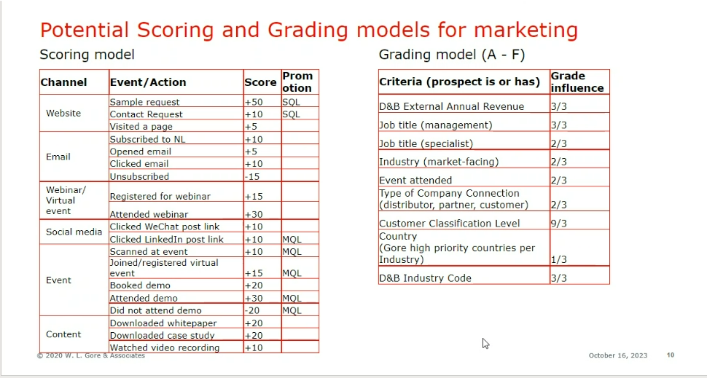

## 13. Marketing Data Migration

This section includes all the Data that will be Integrated into Dataverse Marketing

Marketing would be receiving the data from below sources:

* Ping B2B contacts get split into two parts

1. Ingested into CI, which will be available to Marketing as CI segments
2. Ingested into Dataverse custom tables from CPC

* We would receive data in csv format for the initial import into the Dataverse tables as part of one-time ingestion *refer below table*
* API will be created/managed by Gore team for the ongoing sync
* B2C Contacts are sourced from Formstack and will be directly stored in Dataverse contact entity

|  |  |  |
| --- | --- | --- |
| **Data** | **Source** | **Comments** |
| CI Profile | Customer Insights | To be synced by CI team |
| Elixir B2C Contacts  Elixir B2C Consent | Formstack /Power Automate Trigger | We need to create records for contact entity and contact point consent record based on formstack submission |
| MPD CPC Data  MPD CPC Consent | One time data ingestion from SFMC + PING API Sync going forward | * CSV format files provided by Gore Team and the initial imported to be done by TTEC into CPC tables * Ping API to push data into Dataverse would be implemented by Gore Team |
| PSD CPC Data  PSD CPC Consent | Same as above | Same as above into CPC Tables |
| FAB B2B Data  FAB B2B Consent | Same as above | Same as above |
| Elixir B2B Data  Elixir B2B Consent | Same as above | Same as above |
| COR(College Recruiting) B2B Data  COR B2B Consent | Same as above | Same as above |
| Elixir B2B Data  Elixir B2B Consent | Same as above(Initial Load) | Same as above((Initial Load)) |

## 14. Configuration of Marketing Security Roles (1 Admin ,1 General user) ,6 BU, Access control

|  |  |
| --- | --- |
| **Role Name** | **Access Needed** |
| Gore - Marketing Professional-Business | Create/Update Templates, Emails, Forms  *=> No sending permission (only test sends)* |
| Marketing Manager-Business | Create/Update/Delete Segments  Create/Update/Delete Journeys  Activate and Publish Journeys |

Digital Studio team would be assigned both the above roles so they can work on Marketing app on creation of email campaigns

## 15. Creation of a 1 Native D365 reporting dashboard for Marketing Campaigns

Journey Analytics would include:

* Total Journeys by Start date, Name and Status
* Total Inflow
* Total Engagement Rate

Email Analytics would include

* Delivery Rate
* Open Rate
* Click Rate
* Email Sent/Delivered/Bounced (Reason for Hard/Soft Bounced)

**16.Creation of 3 Triggers ~~1 Trigger~~**

Journey triggers could be created as a Real time custom triggers

We are creating the below Triggers for Journeys –This was not part of the initial estimate

|  |  |  |  |
| --- | --- | --- | --- |
| **S.No** | **Trigger Name** | **Journey Name** | **Trigger Criteria** |
| 1 | Record Update Trigger | Elixir B2C Journey | Based on Elixir B2C Record creation <https://gore.formstack.com/forms/elixir_com_new_persona_try_now> |
| 2 | Real Time Trigger (Kicked off by Power Automate) | FY24 - ME - AcousticDesignGuide Journey Intro | Based on Formstack Form submission |
| 3 | Real Time Trigger (Kicked off by Power Automate) | 1114750 TOF Workwear Double Opt-In | Based on Formstack Form submission |

**17.Platform configuration for all the BU**

We need to add configuration to ensure the

* The Digital Studio is able to perform the regular Marketing functions in Marketing App for different Business Unit.
* They should be able to assign the Business unit for the Marketing elements : Emails,Journeys,Segments etc .

To achieve this based on MVP timelines we would add the below in the Marketing App

* Views created in the CDMA_PRD to easily select and Navigate between BU resources .
* 1 View for each BU per entity for seamless navigation
* Entities Identified so far :Contacts,Leads, Emails ,Email Templates,Segments ,Journeys{*To be added}*
* 1 field “Owning Business Unit” to be added to each of the entity forms in the UI for the team to easily select the Business Unit for a campaign ,email and ensure it is segregated by BU at entity level in Dataverse

Reference link : <https://learn.microsoft.com/en-us/dynamics365/customer-insights/journeys/real-time-marketing-modernized-business-units>

Assumption : We will be doing this as a joint activity based on the Build hours feasibility for the MVP

# 4 Customer Approval

<CLIENT> agrees with the requirements and acceptance criteria presented above.

**<Client Name> TTEC Digital**, LLC

Name:         ` Name:         `

Title:             Title:

Date:                     Date: